Contribution Title

First Author1[0000-1111-2222-3333] and Second Author2[1111-2222-3333-4444] etc.

1 Magnel-Vandepitte Laboratory of Structural Engineering and Building Materials, Tech Lane Ghent Science Park, Campus A, Technologiepark Zwijnaarde 60, B-9052 Gent, Belgium

2 KU Leuven, Department of Civil Engineering, Materials and Constructions, Ghent Campus, Gebroeders de Smetstraat 1, 9000 Ghent, Belgium

Please mark the Corresponding Author with his/her email address

**Abstract.** The abstract should summarize the contents of the paper in short terms, i.e. 300 words; justified between the margins and using the font/size specified below.

**Keywords:** First Keyword, Second Keyword, Third Keyword, Forth Keyword, Sixth Keyword.

This document is a guide for MS Word users. The paper has to be saved as .doc file with the following name structure: **ID_Last name first author_Title.**

Please restrict your document to 8 pages for the full paper.

Page Size, Margins and Font

The page size is standard A4, with the margins listed in Table below. The document is based on the font Times New Roman. The standard font size is 10pt. The paper title is 14pt bold faced. Section titles are 12pt bold faced; subsection titles are 10pt italics. Figure and table captions are 9pt.

|  |  |  |  |  |
| --- | --- | --- | --- | --- |
| Page | Top | Bottom | Left | Right |
| First | 5.0 | 5.6 | 4.7 | 4.6 |
| Rest | 5.0 | 5.6 | 4.7 | 4.6 |

1. First Section
   1. A Subsection Sample

Please note that the first paragraph of a section or subsection is not indented. The first paragraphs that follows a table, figure, equation etc. do not have an indent, either.

Subsequent paragraphs, however, are indented.

Figures/Tables should be centred within the page width and numbered sequentially. Figures/Tables should be numbered separately. Multiple figures should be referred using letters (e.g. Fig. 1a or 1b).

In the text a figure/table is referred as “Fig. 1a shows the drag coefficient...” or “the slope of the lift coefficient switches from negative to positive at the critical Re (Fig. 1b)”.

Do use the table function in Word to create and format tables. Do not use Powerpoint or Excel to create tables. Do not submit tables as image files.

Tables are published in black and white.

### Sample Heading (Third Level). Only two levels of headings should be numbered. Lower level headings remain unnumbered; they are formatted as run-in headings.

#### Sample Heading (Forth Level). The contribution should contain no more than four levels of headings. The following Table 1 gives a summary of all heading levels.

**Table 1.** Table captions should be placed above the tables.

|  |  |  |
| --- | --- | --- |
| Heading level | Example | Font size and style |
| Title (centered) | **Lecture Notes** | 14 point, bold |
| 1st-level heading | **1 Introduction** | 12 point, bold |
| 2nd-level heading | **2.1 Printing Area** | 10 point, bold |
| 3rd-level heading | **Run-in Heading in Bold.** Text follows | 10 point, bold |
| 4th-level heading | *Lowest Level Heading.* Text follows | 10 point, italic |

Displayed equations are centered and set on a separate line, and numbered sequentially.

Do use the Math function, MathType, or Microsoft Equation editor to create your equations. Please don’t include the equations as images.

Equations must be referred in the text as “Eq. (1) defines strain sensitivity”. Equations must be referred in the text as “Eq. (1)” for one equation or “Eqs. (1), (2) and (3)” for multiple equations.

*x* + *y* = *z* ()

Please try to avoid rasterized images for line-art diagrams and schemas. Whenever possible, use vector graphics instead (see Fig. 1).

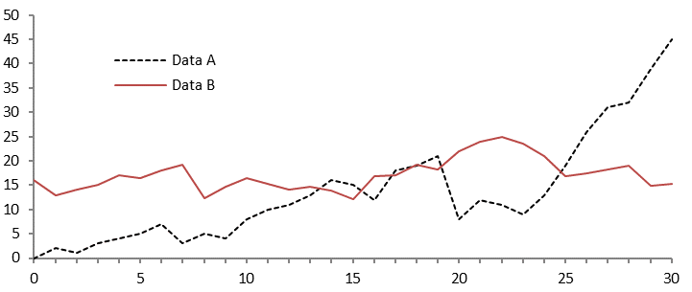

**Fig. 1.** A figure caption is always placed below the illustration. Short captions are centered, while long ones are justified. The macro button chooses the correct format automatically.

For citations of references, please use square brackets and consecutive numbers. The following bibliography provides a sample reference list with entries for journal articles [1], an LNCS chapter [2], a book [3], proceedings without editors [4], as well as a URL [5].

References

1. Author F (2016) Article title. Journal 2(5):99–110.
2. Author F, Author S (2017) Title of a proceedings paper. In: Editor F, Editor S (eds.) Proceedings Title, pp. 1–13. Springer, Heidelberg.
3. Author F, Author S, Author T (1999) Book title. 2nd edn. Publisher, Location.
4. Author F (2010) Contribution title. In: 9th International Proceedings on Proceedings, pp. 1–2. Publisher, Location.
5. LNCS Homepage, <http://www.springer.com/lncs>, last accessed 2016/11/21.